Date: _______________________________________

Submitter Name: _______________________________________

Submitter Return Address: ____________________________________________________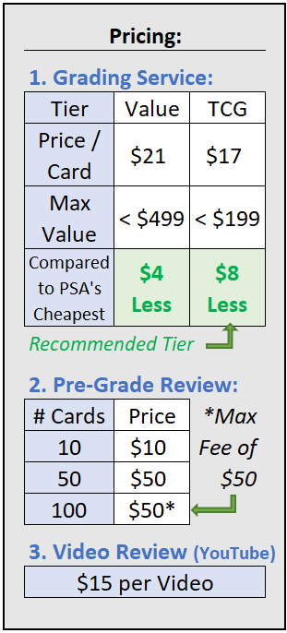

***(Your cards will be shipped to this address)***

Submission Information:

1. PSA Tier (Value or TCG): _______________
2. # cards being submitted: _____________(2)
3. # cards being reviewed: _____________(3)
4. Requesting video review? _____________(4)

Submission Pricing Calculation:

1. ____________ x **$17** if TCG Tier = _________(A)

# from line (2) above **$21** if Value Tier

1. ____________ x **$1** / card = _________(B)

# from line (3) above (Max $50)

1. ____________ → If Yes, write **$15** on “C” → _________(C)

Yes or No from (4) above

1. __________ + __________ + __________ = **___________ Total $ Due**

Total from (A) Total from (B) Total from (C) (Total due prior to shipping)

Next Steps:

1. Please email your completed forms to [flwer.cty.crds@gmail.com](mailto:flwer.cty.crds@gmail.com) .
   1. In the email title please provide your name followed by “PSA Submission”  
       **Example Email Title: John Smith PSA Submission**
2. Submit payment (**Total $ Due**) using **options I provide to you via private message.**
3. Safely package your cards and mail them to the **address I will provide to you via private messages.** I recommend using [www.pirateship.com](http://www.pirateship.com) for significantly cheaper prepaid shipping labels. They also offer insured shipping options (highly recommended). Please provide me tracking so I can monitor them as they move through the network.
4. Once I receive your cards, I will process them & submit them to PSA. From there I will provide updates periodically as they move through the grading process. **If at any time you would like status simply reach out to me and I can provide one to you.**
5. Once the cards have been graded & received, I will ship them back to you. **I will bill you for insured shipping costs which will be required prior to shipping your cards.**
   1. Upon PSA processing your cards I can also provide the grade results. Some prefer to wait until they receive them - but they can be provided upon request!